AIMS Software |  | Date of creation | Approved by | Reviewed by | Person in charge
Screen specification | Cart Screen | 30/10/2023 |  |  | Đỗ Minh Hiếu
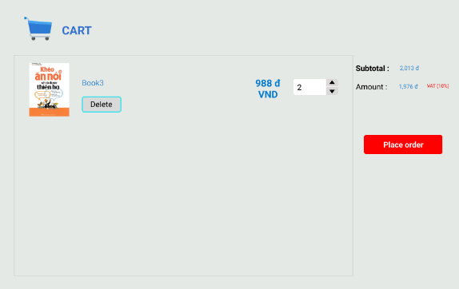 |  | Control | Operation | Function
 |  | Area for displaying the subtotal | Initial | Display the subtotal
 |  | Area for display items in the cart | Initial | Display the media with the corresponding information
 |  | Place order button | Click | Display the Delivery form
 |  | Delete button | Click | Remove the item from the cart
Screen specification | Delivery Form 1 | 30/10/2023 |  |  | Đỗ Minh Hiếu
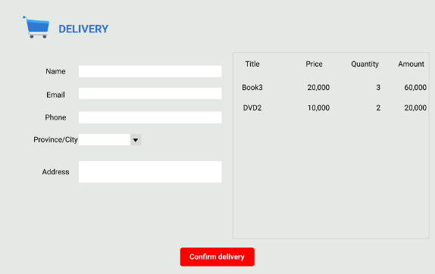 |  | Control | Operation | Function
 |  | Area for displaying delivery information | Initial | Get the delivery information from customer
 |  | Area for display items in the cart | Initial | Display the media with the corresponding information
 |  | Confirm delivery button | Click | Submit delivery information
Screen specification | Delivery Form 2 | 30/10/2023 |  |  | Đỗ Minh Hiếu
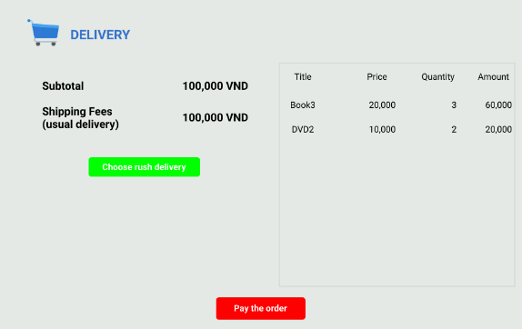 |  | Control | Operation | Function
 |  | Area for displaying shipping fee | Initial | Display the shipping fee of usual delivery
 |  | Area for display items in the cart | Initial | Display the media with the corresponding information
 |  | Pay the order button | Click | Pay the order
 |  | Choose rush delivery button | Click | Display the rush delivery form
Screen specification | Rush Delivery Form 1 | 30/10/2023 |  |  | Đỗ Minh Hiếu
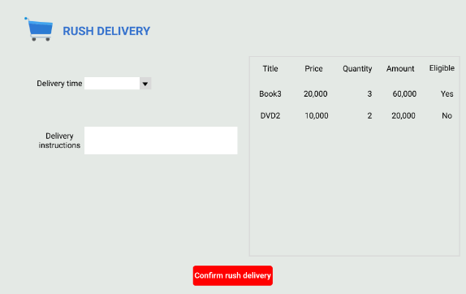 |  | Control | Operation | Function
 |  | Area for displaying rush delivery information | Initial | Get the additional rush delivery information from customer
 |  | Area for display items in the cart | Initial | Display the media with the corresponding information including eligibility for rush delivery
 |  | Confirm rush delivery button | Click | Submit additional rush delivery information
Screen specification | Rush Delivery Form 2 | 30/10/2023 |  |  | Đỗ Minh Hiếu
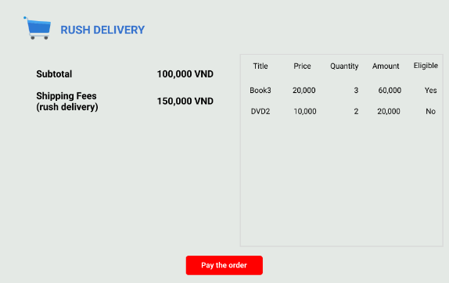 |  | Control | Operation | Function
 |  | Area for displaying shipping fee | Initial | Display the shipping fee of rush delivery
 |  | Area for display items in the cart | Initial | Display the media with the corresponding information including eligibility for rush delivery
 |  | Pay the order button | Click | Pay the order
Screen specification | Invoice Screen | 30/10/2023 |  |  | Đỗ Minh Hiếu
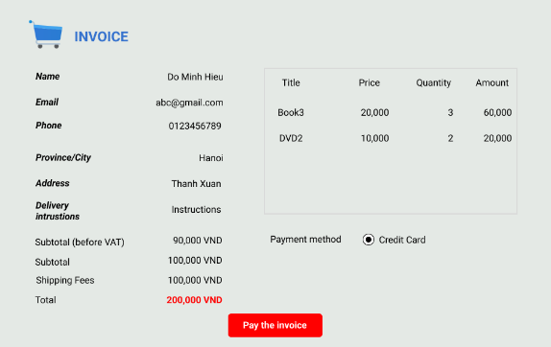 |  | Control | Operation | Function
 |  | Area for displaying delivery information | Initial | Display the delivery submitted by customer
 |  | Area for display items in the order | Initial | Display the media with the corresponding information
 |  | Area for display the subtotal | Initial | Display the subtotal and amount including shipping fee
 |  | Area for display the payment method | Click | To choose the payment method
 |  | Pay the invoice butotn | Click | Redirect to VNPay to make purchases
Screen specification | Success Order Screen | 30/10/2023 |  |  | Đỗ Minh Hiếu
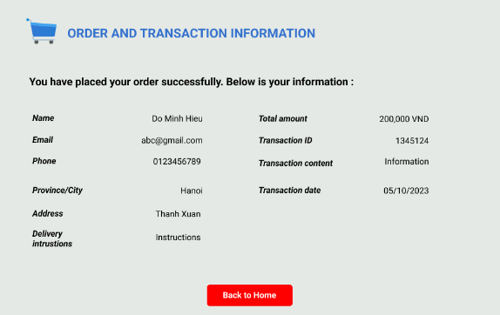 |  | Control | Operation | Function
 |  | Area for displaying message | Initial | Display the successful order message
 |  | Area for display order and transaction information | Initial | Display the order and transaction information
 |  | Back to Home button | Click | Back to home page

Defining the field attributes

Screen name | Cart Screen
Item name | Number of digits (bytes) | Type | Field attribute | Remarks
Title | 50 | Numeral | Black | Left-justified
Price | 20 | Numeral | Black | Right-justified
Subtotal | 20 | Numeral | Blue | Right-justified
Amount | 20 | Numeral | Blue | Right-justified

Screen name | Delivery Form 1
Item name | Number of digits (bytes) | Type | Field attribute | Remarks
Name | 50 | String | Black | Left-justified
Email | 50 | String | Black | Left-justified
Phone | 20 | String | Black | Left-justified
Province/City | 20 | String | Black | Left-justified
Address | 200 | String | Black | Left-justified
Title | 50 | String | Black | Right-justified
Price | 20 | Numeral | Black | Right-justified
Quantity | 20 | Numeral | Black | Right-justified
Amount | 20 | Numeral | Black | Right-justified

Screen name | Delivery Form 2
Item name | Number of digits (bytes) | Type | Field attribute | Remarks
Subtotal | 20 | Numeral | Black | Right-justified
Shipping Fees | 20 | Numeral | Black | Right-justified
Title | 50 | String | Black | Right-justified
Price | 20 | Numeral | Black | Right-justified
Quantity | 20 | Numeral | Black | Right-justified
Amount | 20 | Numeral | Black | Right-justified

Screen name | Rush Delivery Form 1
Item name | Number of digits (bytes) | Type | Field attribute | Remarks
Delivery time | 100 | Date time | Black | Left-justified
Delivery instructions | 200 | String | Black | Left-justified
Title | 50 | String | Black | Right-justified
Price | 20 | Numeral | Black | Right-justified
Quantity | 20 | Numeral | Black | Right-justified
Amount | 20 | Numeral | Black | Right-justified
Eligible | 3 | String | Black | Right-justified

Screen name | Rush Delivery Form 2
Item name | Number of digits (bytes) | Type | Field attribute | Remarks
Subtotal | 20 | Numeral | Black | Right-justified
Shipping Fees | 20 | Numeral | Black | Right-justified
Title | 50 | String | Black | Right-justified
Price | 20 | Numeral | Black | Right-justified
Quantity | 20 | Numeral | Black | Right-justified
Amount | 20 | Numeral | Black | Right-justified
Eligible | 3 | String | Black | Right-justified

Screen name | Invoice Screen
Item name | Number of digits (bytes) | Type | Field attribute | Remarks
Name | 50 | Numeral | Black | Right-justified
Email | 20 | Numeral | Black | Right-justified
Phone | 20 | Numeral | Black | Right-justified
Province/City | 20 | String | Black | Right-justified
Address | 200 | String | Black | Right-justified
Delivery instructions | 200 | String | Black | Right-justified
Title | 50 | String | Black | Right-justified
Price | 20 | Numeral | Black | Right-justified
Quantity | 20 | Numeral | Black | Right-justified
Amount | 20 | Numeral | Black | Right-justified
Subtotal (before VAT) | 20 | Numeral | Black | Right-justified
Subtotal | 20 | Numeral | Black | Right-justified
Shipping Fees | 20 | Numeral | Black | Right-justified
Total | 20 | Numeral | Red | Right-justified

Screen name | Success Order Screen
Item name | Number of digits (bytes) | Type | Field attribute | Remarks
Name | 50 | Numeral | Black | Right-justified
Email | 20 | Numeral | Black | Right-justified
Phone | 20 | Numeral | Black | Right-justified
Province/City | 20 | String | Black | Right-justified
Address | 200 | String | Black | Right-justified
Delivery instructions | 200 | String | Black | Right-justified
Total amount | 20 | Numeral | Black | Right-justified
Transaction ID | 20 | Numeral | Black | Right-justified
Transaction content | 200 | String | Black | Right-justified
Transaction date | 100 | Date | Black | Right-justified

